`

Online Banking System

**Team Members:**

|  |  |
| --- | --- |
| **Full Name** | **Employee Id** |
| **Soham Purohit** | **46022721** |
| **Deepanshu Pathak** | **46022110** |
| **Praveen Kumar** | **46022712** |

Table of Contents

1. Introduction ------------------------------------------------------------------------------------
2. Overview-----------------------------------------------------------------------------------------
3. Team Member Work Allocation-------------------------------------------------------------
4. Epic & Stories -----------------------------------------------------------------------------------
5. Use Cases ----------------------------------------------------------------------------------------
   * 1. Admin Functionalities----------------------------------------------------------------------
6. Login ---------------------------------------------------------------------
7. Add new customer ---------------------------------------------------------------------
8. Request Handling------------------------------------------------------------------
9. View Report ------------------------------------------------------------
   * 1. Customer Functionalities-----------------------------------------------------------

A) Registration--------------------------------------------------------------------

B) Login----------------------------------------------------------------

C) Update-----------------------------------------------------------------

D) Request Service-----------------------------------------------------

E) Track Service Request----------------------------------------------

F) Transaction------------------------------------------------------------

G) View Detail ----------------------------------------------------------------

1. Class Diagram ----------------------------------------------------------------------------------
2. System Requirement--------------------------------------------------------------------------
3. Conclusion----------------------------------------------------------------------------------------

1. Introduction

Online banking, also known as internet banking or web banking, is an electronic payment system that enables customers of a [bank](https://en.wikipedia.org/wiki/Bank) or other [financial institution](https://en.wikipedia.org/wiki/Financial_institution) to conduct a range of [financial transactions](https://en.wikipedia.org/wiki/Financial_transaction) through the financial institution's website. The online banking system will typically connect to or be part of the [core banking](https://en.wikipedia.org/wiki/Core_banking) system operated by a bank and is in contrast to [branch banking](https://en.wikipedia.org/wiki/Branch_banking) which was the traditional way customers accessed banking services.

Online Banking is one of the most important financial activities which will be carried out by any person who holds a bank account. There are various activities that can be carried out once you log in to your bank account. Once a user logs in he or she can check the bank balance, check bank account transaction history or account summary, add beneficiary accounts, transfer funds to another account, download account summary. Whenever we deal with a banking system main concern should be the security related to banking transactions and account login activity.

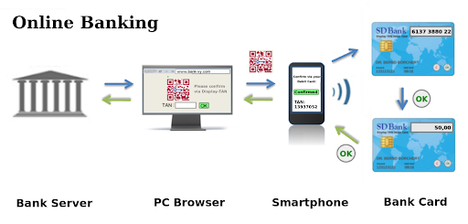

Online Banking have following Module:

1. Customer  
2. Registration module  
3. Security and Authentication  
4. Accounts summary  
5. Transfer Funds  
6. Profile  
7. Admin

2.Overview

Online Banking have the following functional requirements:

* Customer can open bank account.
* Transactions
* Update details.
* Request service.
* Admin can view reports.
* Analyse the transactions.

The main objective of our project is to provide more security while performing online transaction by providing efficient authentication etc. In the existing system, we can perform all the operations using a single user id and password. Once this password is stolen, it is easy for the others to access all the operations like transfer of money etc., so that the customer could pay a huge loss. Thus it is not secured up to mark. In our project, we provide much security to the customer while using the online banking service in the following ways. The customer using the online banking service would be given user id along with two other passwords. One called Login Password and the other called transaction password. By using login password the customer can login to be account and we can perform only some (limited) operations like viewing A/C balance and personal details and account details etc. But to perform transfer or online transaction, the user needs to provide the transaction password and other secure information in order to complete the transaction successful.

If the customer login password and id is stolen by someone else, he can see the details but he can’t perform online transaction or transfer.

Here admin can view and analyse the report of the transactions of the customers . Report can be analysed on the basis of monthly , quarterly , and yearly.

3. Team Member Work Allocation

The project is having two Modules: customer and admin. The work is divided based on the module and its functionalities.

**Admin module is handled by:**

Deepanshu Pathak (Employee id- 46022110)

**Customer module is handled by:**

Praveen Kumar (Employee id- 46022712) and

Soham Purohit (Employee id- 46022721)

4. Epic & Stories

|  |  |  |  |  |
| --- | --- | --- | --- | --- |
| Epic | Stories | As a/an | I want to | So that .. |
| Customer | Register | User | Register into the system | A new user is added to the database. |
| Login | User | Login to the system | I’m logged in to use my functionalities. |
| View Details | User | View the detail  Related to my account | Check and insure about my account balance my personal details. |
| Update | User | Update details | I’m able to update the personal details and password. |
| Request | User | Request facilities | I can use services that provided by the bank. |
| Transaction | User | Transfer money | I can do transactions. |
| Track Requests | User | Track my request | See the status of request. |

|  |  |  |  |  |
| --- | --- | --- | --- | --- |
| Epic | Stories | As a/an | I want to | So that .. |
| Admin | Login | Admin | Login to the system | I’m logged in to use my functionalities. |
| Create account | Admin | Add new account | I can add a new user on request. |
| View Details | Admin | View details | View the customers List details . |
| Analyse Details | Admin | Analyse | I can study the reports and analyse the data. |

5. Use Cases

5.1 Admin

Overview

Admin module is the core in any online system as admin has the full control over the system. Logging-in, creating new account, view all details, generating reports and analysing the reports like number of customer, total amount transfer, each month data report and calculative analysis to improve the management day by day. Our software uses authorization so that only authorized admin can use the admin functionalities, i.e. Role Mapping.

Designed and Implemented By:

Deepanshu Pathak (Id : **46022110**)

Designation: Senior Analyst/ A5

Use Case Diagram for Admin:

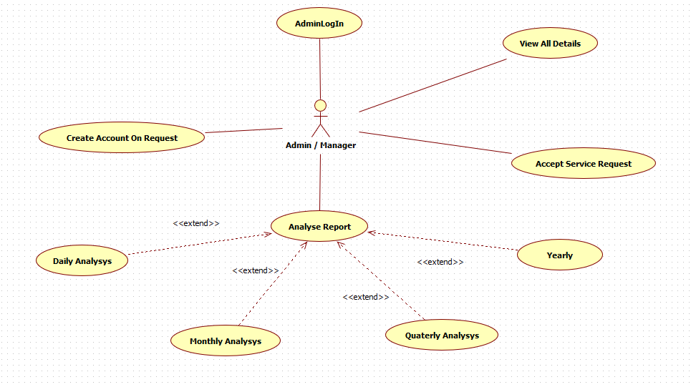

* Admin Login

The form uses authorization mechanism, so that only the authorized user can perform

admin functionalities.

* Add New Customer/Account

The “Add New Customer” functionality is designed to add new customer into the System Database. This functionality is based on the request enter by the user.

* Request Handling

The Admin can differentiate between the request that which one is to be approved and which one can be rejected on the basis of the analysing the report.

* View all Details

This functionality is designed to generate various type of reports, namely,

Transaction report.

Customer Request Reports

Updated Information

Sequence Diagram Admin:

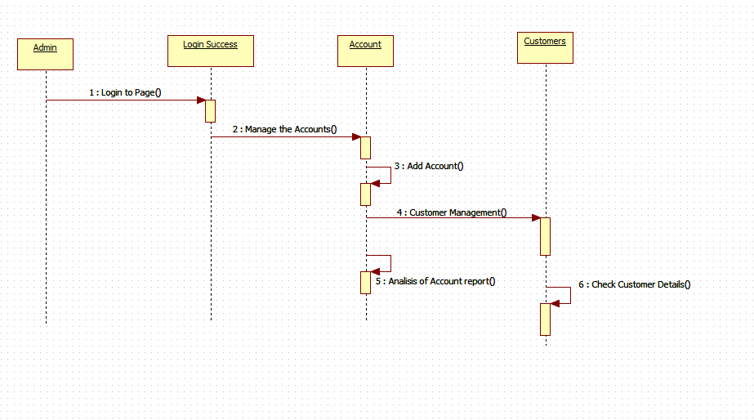

5.2 Customer

Customer are like one of the important part of every banking system. The word customer signifies a relationship in which duration is not of essence. A person whose money has been accepted by the banker on the footing that he undertakes to honour cheques unto the amount standing to his credit is a customer of the bank irrespective of whether his connection is short or long duration.

Designed and Implemented By:

Soham Purohit(Id : **46022721**)

Praveen Kumar (Id:46022712)

Designation: Senior Analyst/ A5

Use Case Diagram for Customer:

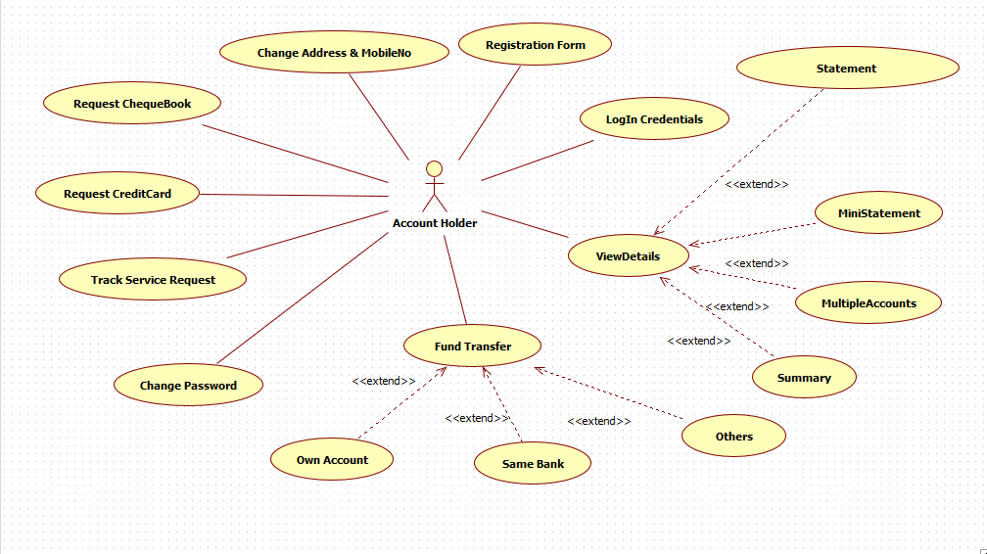

* Customer Login

The form uses authorization mechanism, so that only the authorized user can perform

customer functionalities.

* Registration Form

This form contains the field that hold the user detail and on submit it will be sent to admin for the approval of account on the basis of aadhar number.

* Update

User will able to update the personal information accordingly.

* Request Service

User can use different service that will be provided the bank like credit card, Cheque book.

* Track Service Request

User can track the request what he/she has applied for in order to get the current status

Of their request.

* Transfer Amount/Transaction

User can send amount from their account to different account. Account can be of same

Bank or different bank.

* View Detail

User can view their daily, monthly, and yearly transaction detail. Can also view their personal detail and account summary.

Sequence Diagram for User Login:

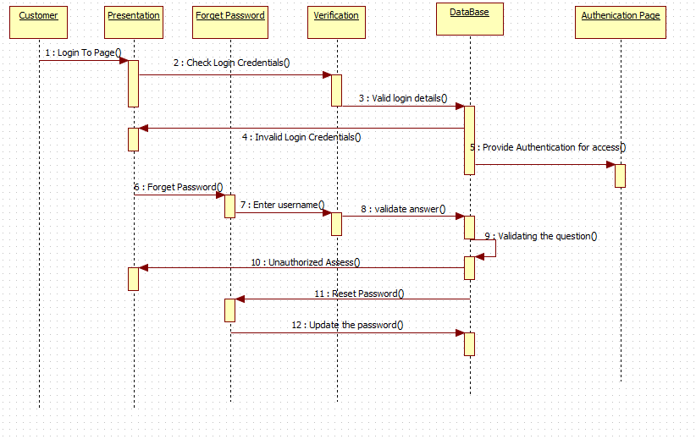

Sequence Diagram for Customer functionalities:

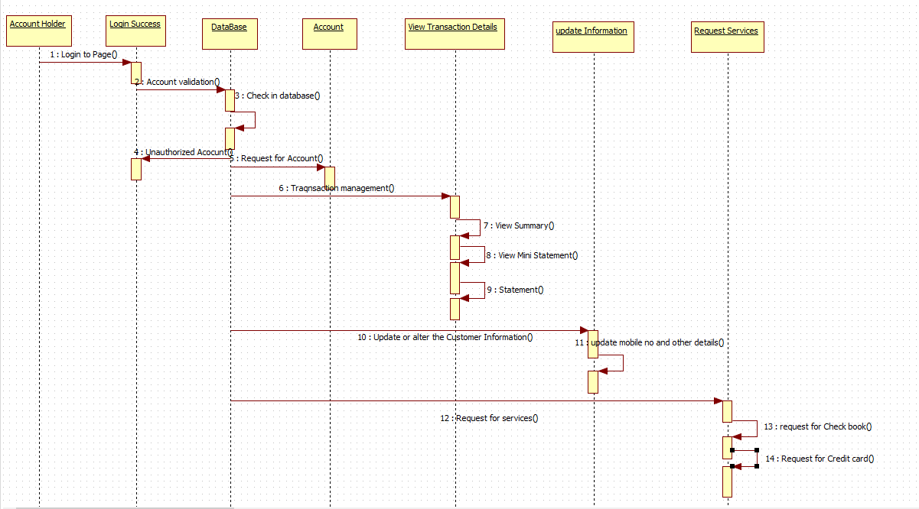

6. Class Diagram

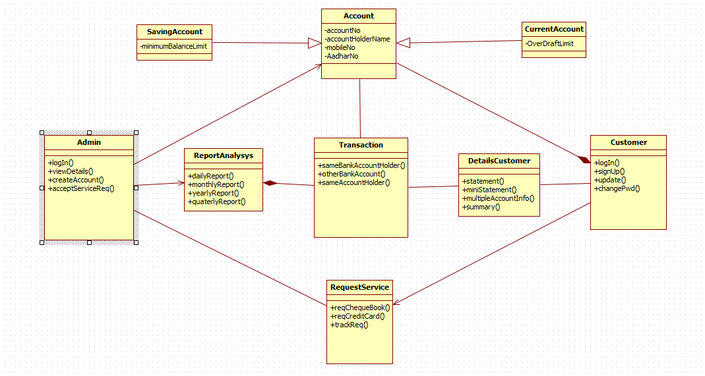

Class diagram will show you the number of class and their connectivity among themselves. It also show the dependency between the class.

10. System Requirements

Below is a list of the minimum Hardware and Software requirements to access Great Outdoors website.

**Operating System:**

* Windows 7 and above.
* Mac OSX 10.8, 10.9, 10.10 or 10.11
* Android 3 and onwards.

**Hardware:**

* Processor (CPU) with 2 gigahertz (GHz) frequency or above
* A minimum of 4 GB of RAM
* Monitor Resolution 1024 X 768 or higher (For better view)
* A minimum of 5 GB of available space on the hard disk
* Internet Connection Broadband (high-speed) Internet connection with a speed of 2 Mbps or higher
* Keyboard and a Mouse or some other compatible pointing device

**Browsers:**

* Chrome* 58+
* Microsoft Edge* 20+
* Mozilla Firefox 40+
* Internet Explorer 11+ (Windows only)
* Safari 6+ (MacOS only)
* Android* 3+

*Google Chrome version 42+ and Microsoft Edge do not support NPAPI-type plug-ins, including Java plug-ins and many media browser plug-in.

Users using unsupported browsers may experience issues submitting forms, placing orders, purchasing, updating details and transaction management threads.

Browser Configuration:

Your browser must be configured as follows:

* Strongly Recommended--add [www.greatoutdoors.com](http://www.greatoutdoors.com/) to trusted sites.
* JavaScript must be enabled
* CORS must be configured properly
* Cookies must be enabled.
* Pop-up windows must be enabled.

**Software:**

* Java — to view and interact with all available blackboard applications.
* Eclipse — Eclipse workbench was used to run JDK (write, compile and run the code).
* Visual Studio Code — for writing codes for frontend using angular, VS Code was used as a workbench.
* Apache Tomcat — it was used as a server for hosting the website.